IEEE 754 Floating Point Addition And Subtraction(Half Precision) Flowcharts

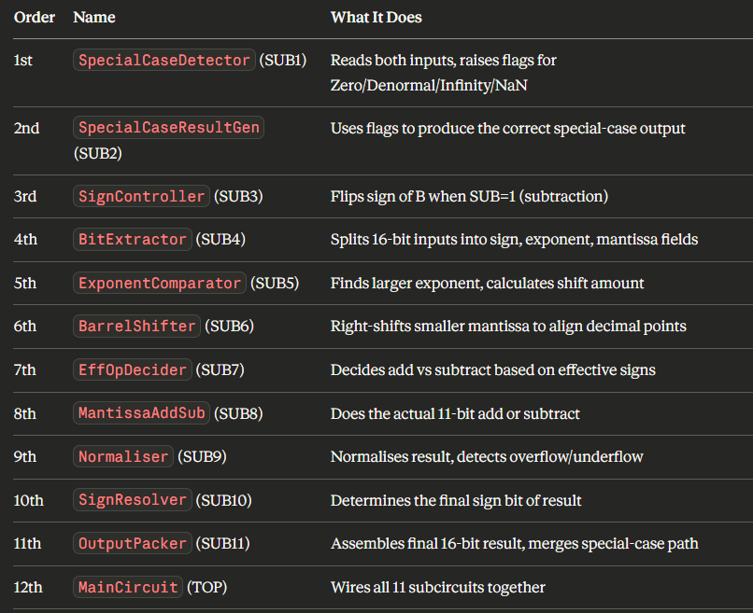

Subcircuit Flowchart:
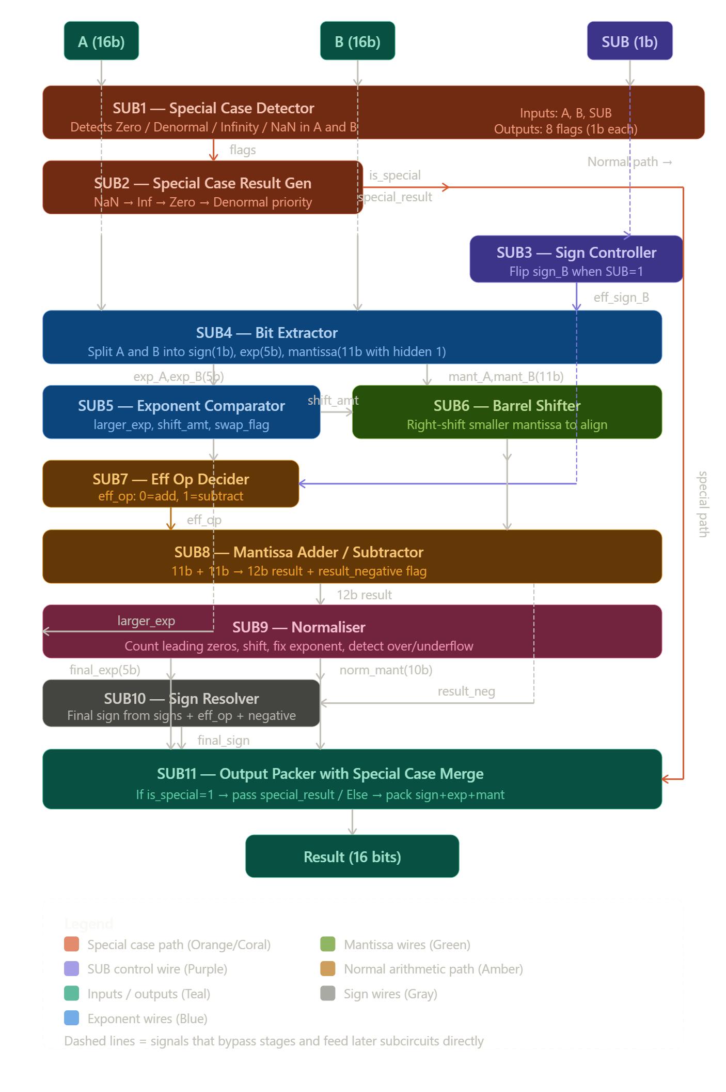
Subcircuit 1:Special Case Detector
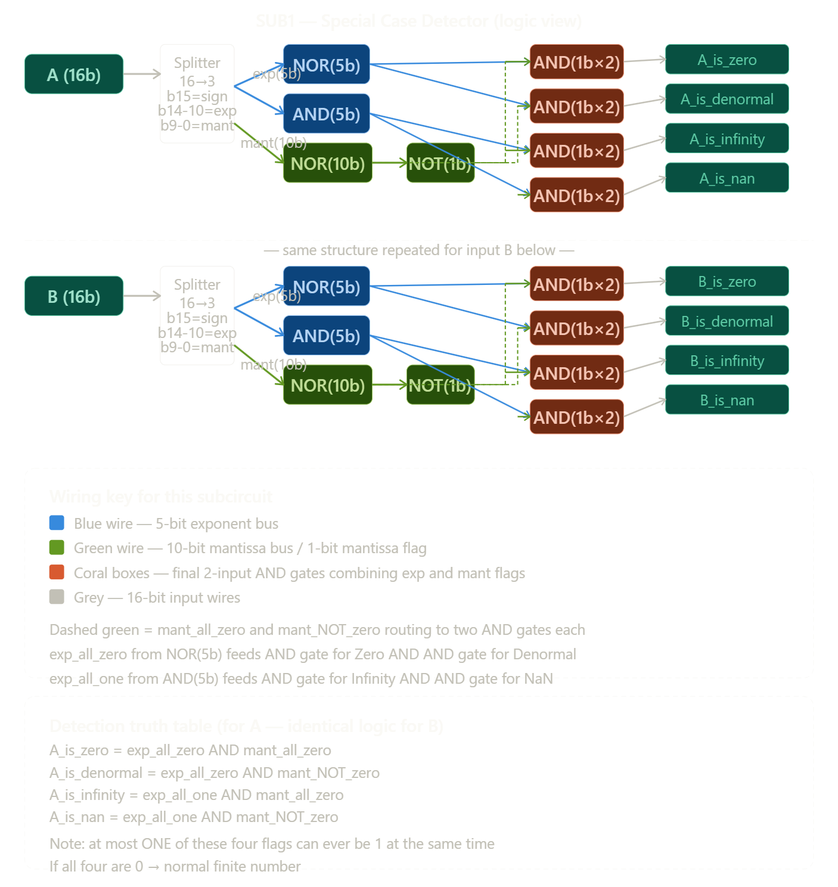

Subcircuit 2:Special case result generator
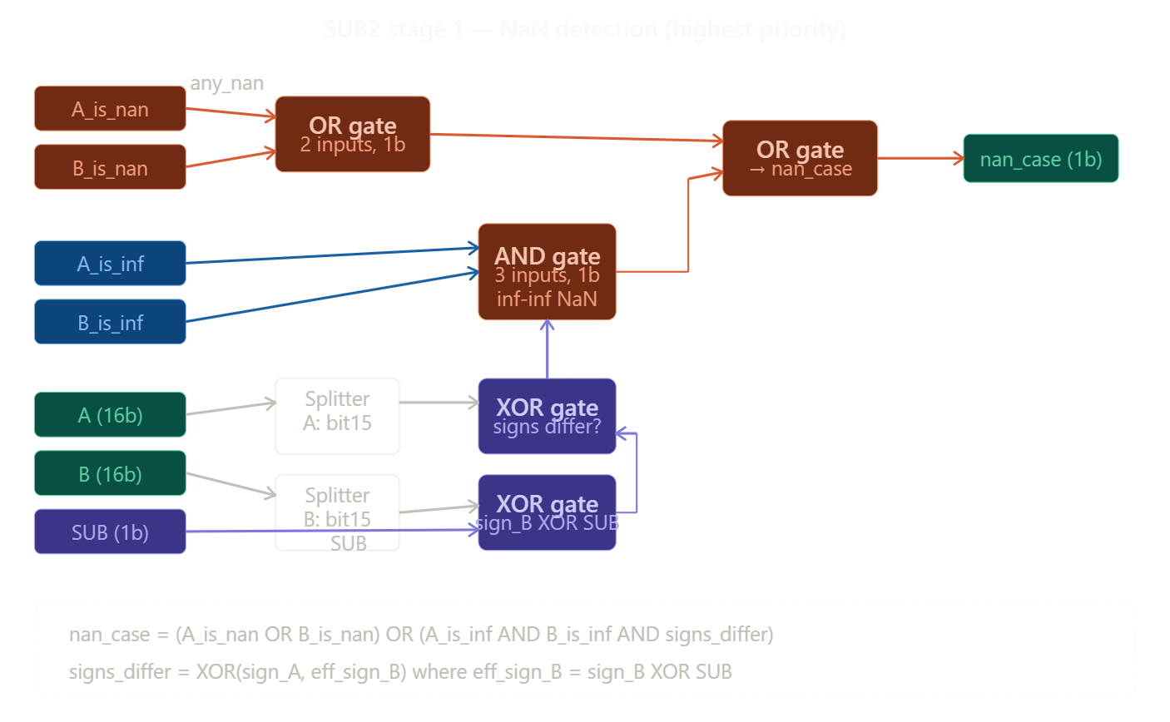
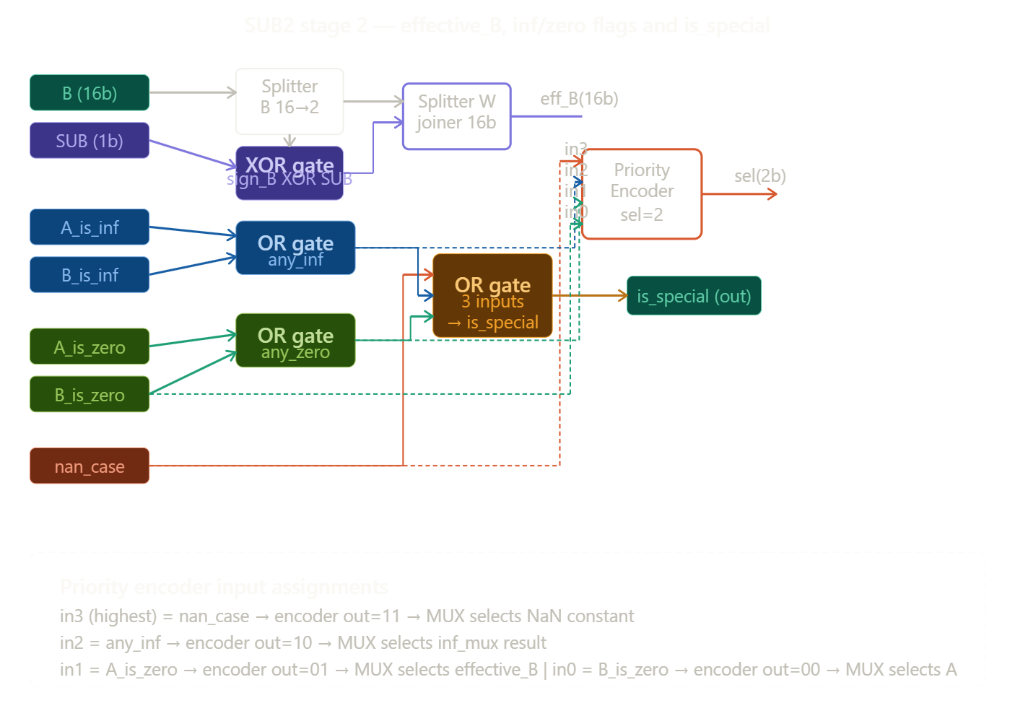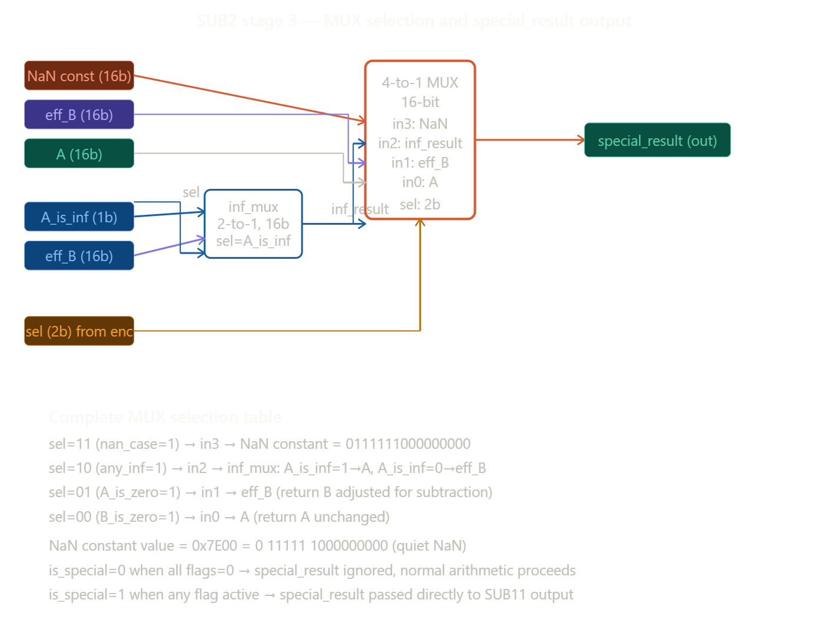
Subcircuit 3:Sign Controller
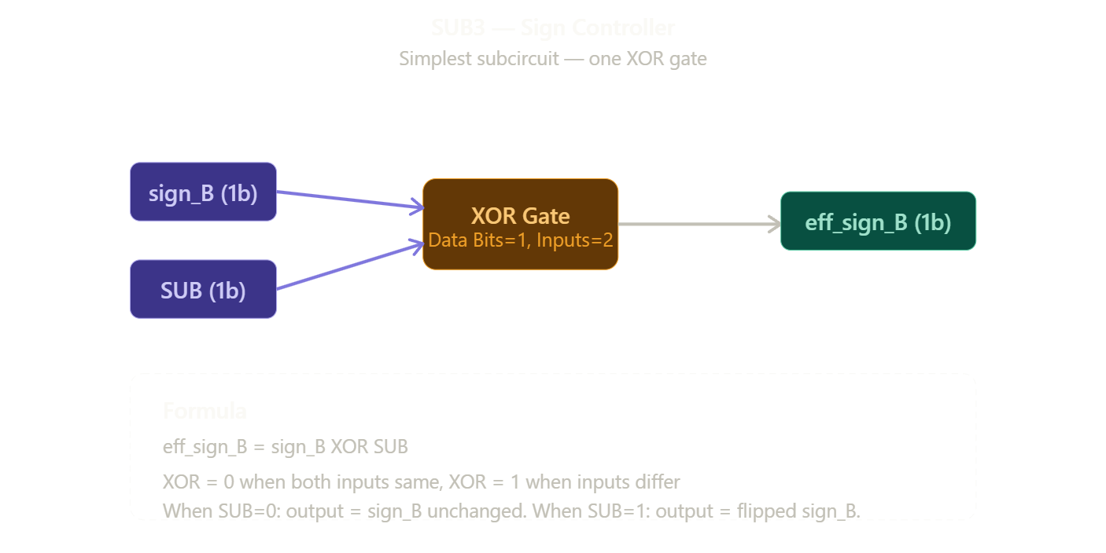
Subcircuit 4:Bit Extractor
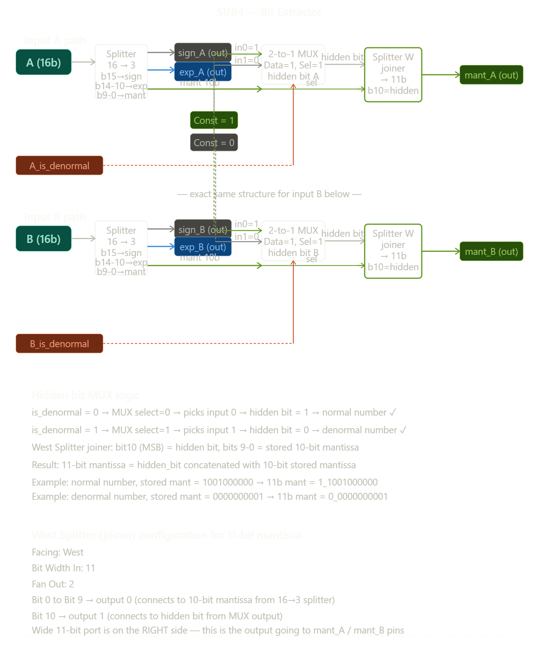

Subcircuit 5:Exponent Comparator
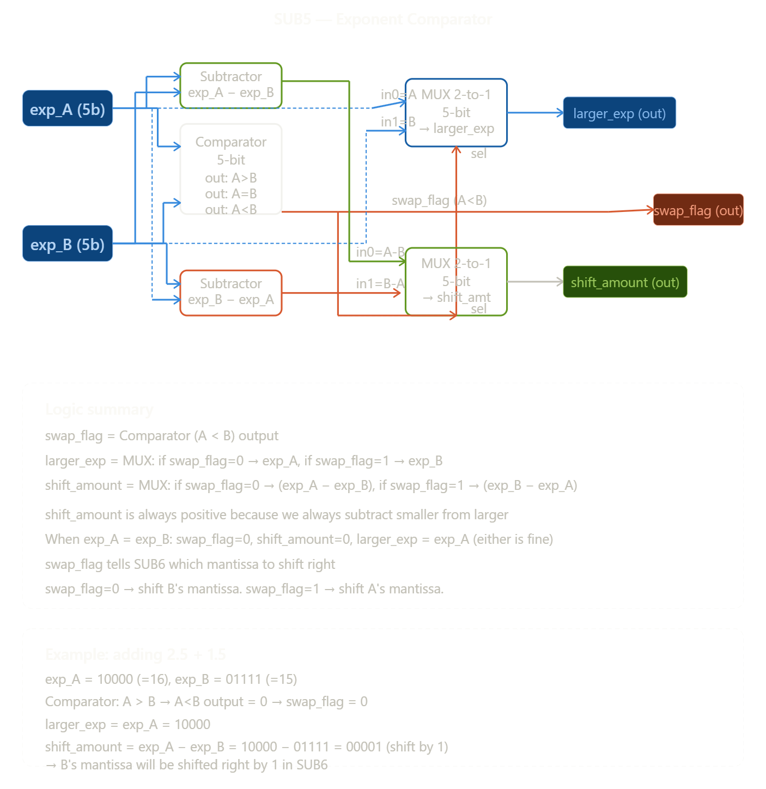

Subcircuit 6:Barrel Shifter
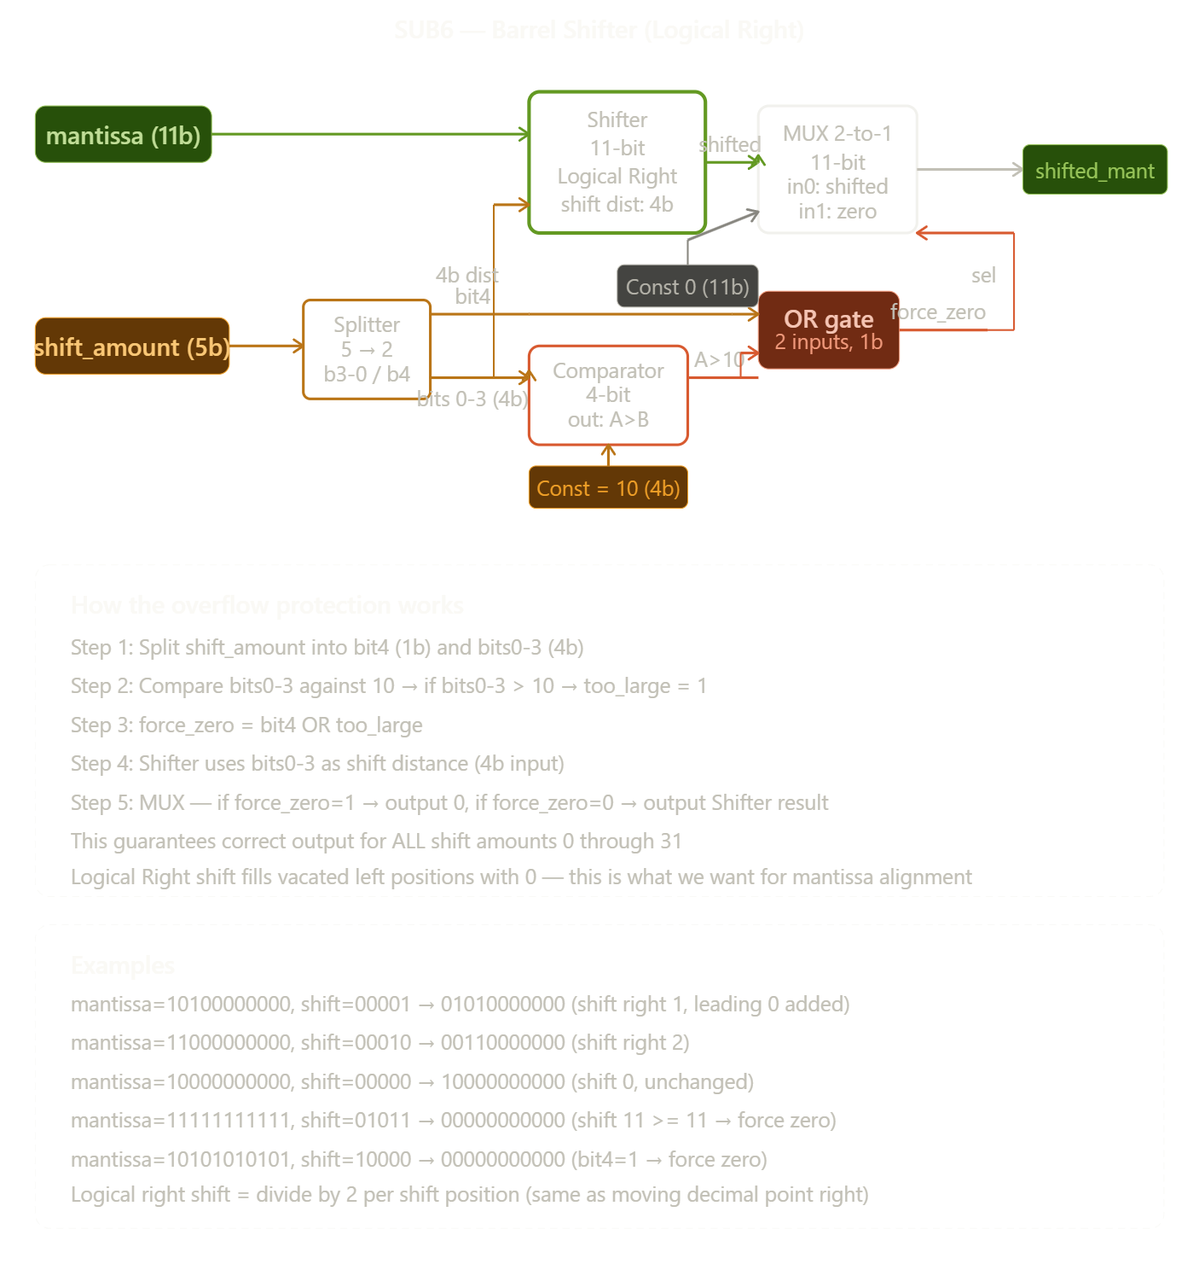

Subcircuit 7:Effective Operation Decider
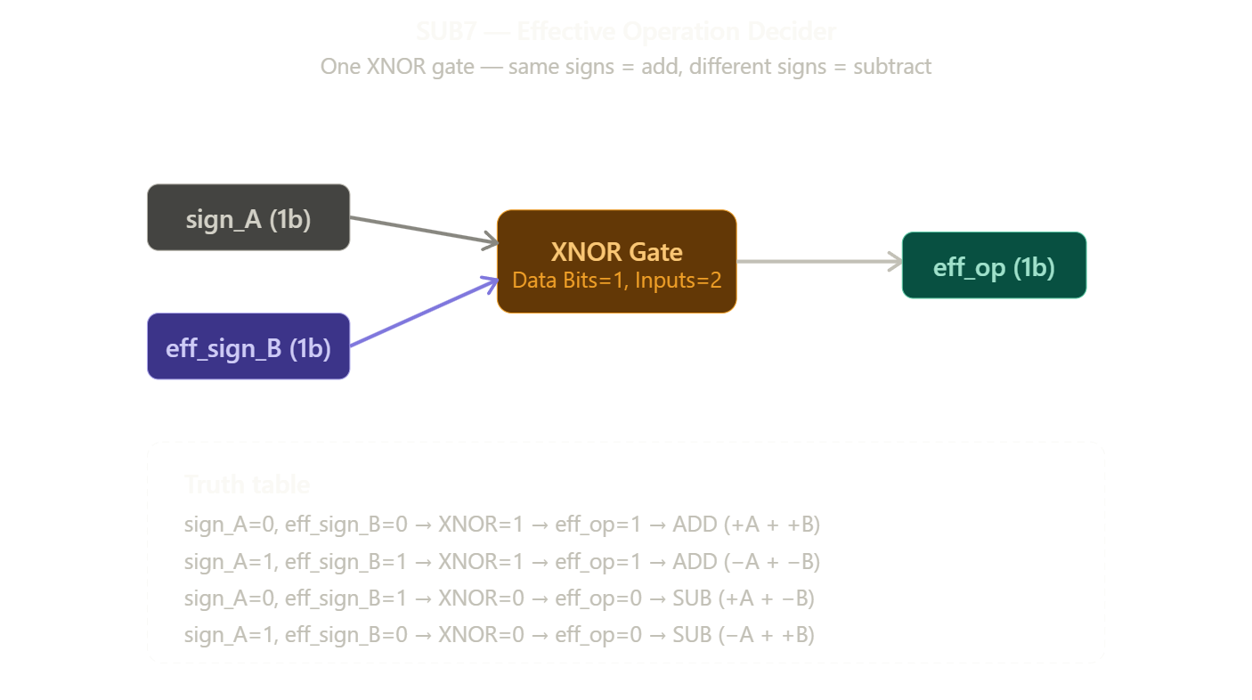

Subcircuit 8:Mantissa ADD and SUBTRACT
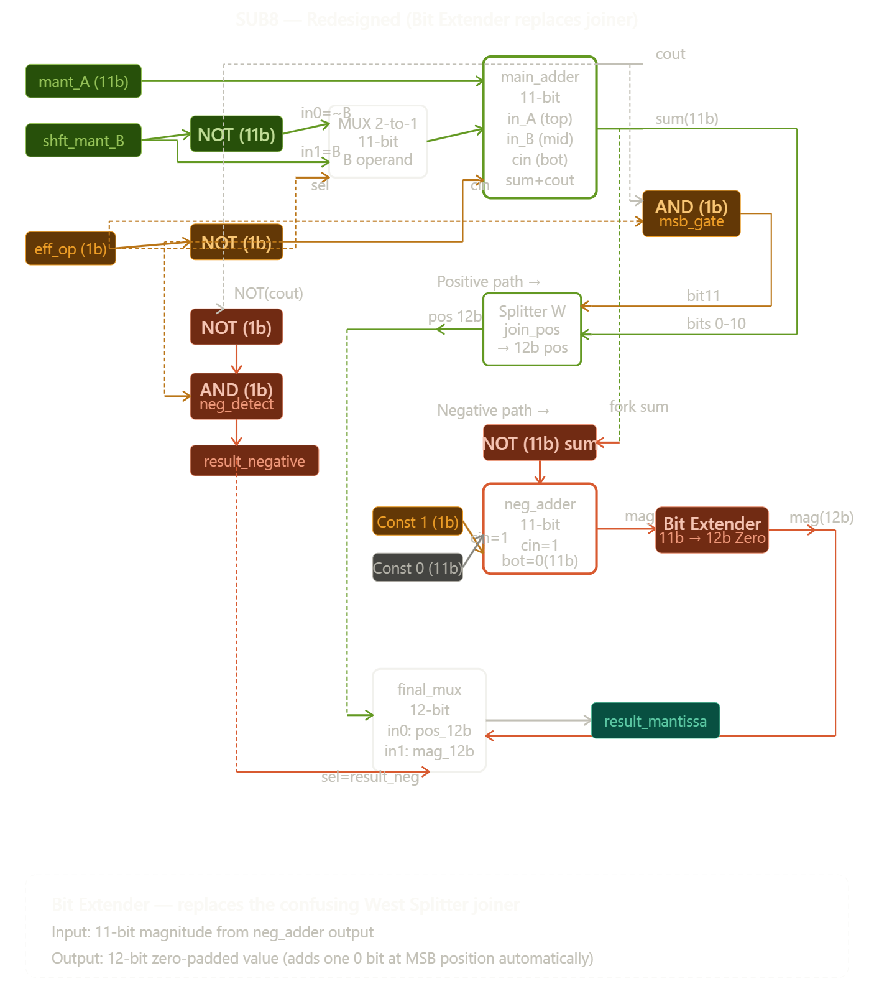

Subcircuit 9:Normaliser
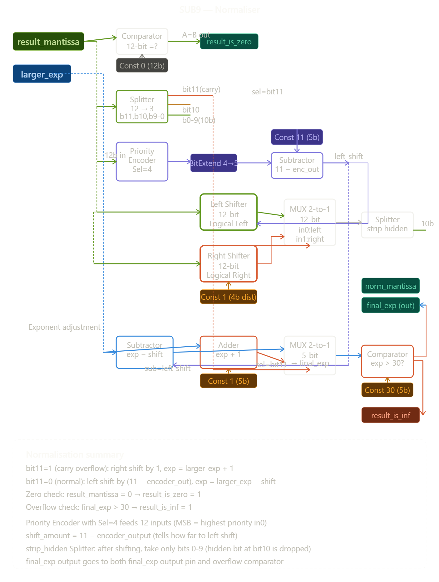
Subcircuit 10: Sign Resolver
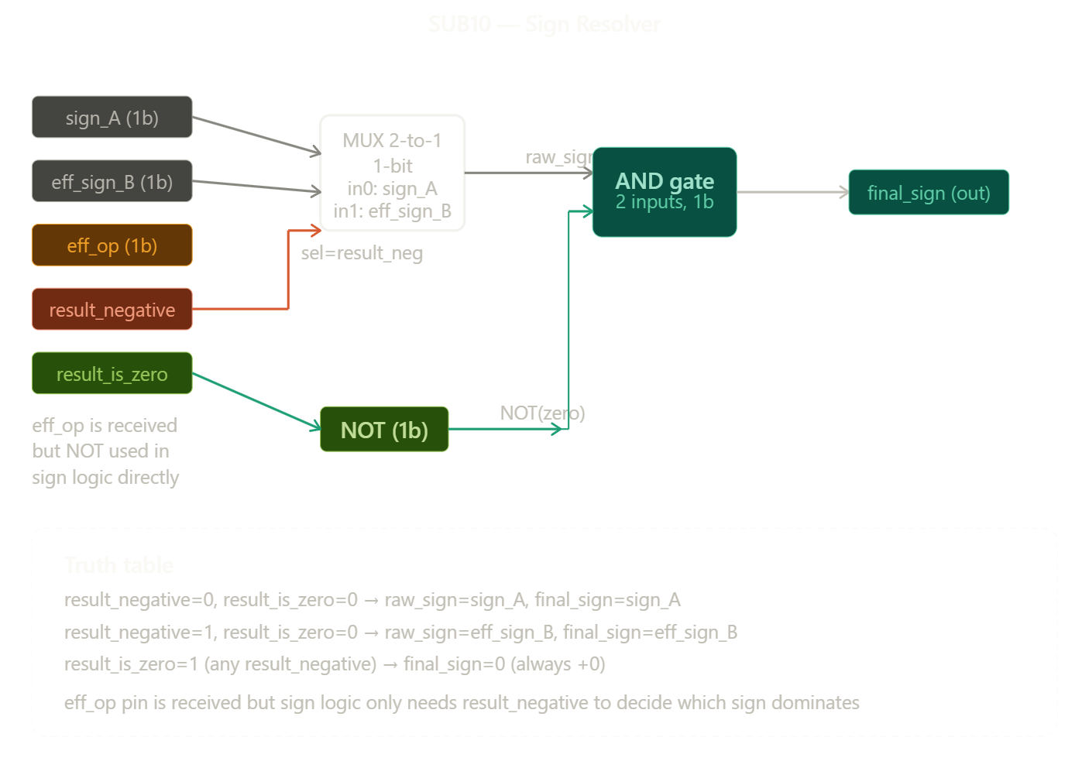

Subcircuit 11:Output Packer
